Experiment no.: 03

Title: Create Digital Signature document using Cryptool.
Course outcome: Demonstrate the use of cryptool.
Theory:

A digital signature is a cryptographic technique used to verify the authenticity, integrity, and non-repudiation of a digital document. It ensures that the document has not been altered after signing and that it truly originates from the claimed sender.
CrypTool is an educational software that demonstrates various cryptographic algorithms and techniques, including the creation of digital signatures. In this process, the sender generates a hash value of the document using a hashing algorithm (like SHA-256) and then encrypts this hash with their private key. The resulting encrypted hash is the digital signature. The receiver can verify the signature by decrypting it with the sender’s public key and comparing the hash values.
This method ensures secure communication by confirming the sender’s identity and maintaining document integrity. Using CrypTool helps visualize and understand how real-world digital signatures function in cybersecurity and electronic authentication systems.

Advantages:
- Authenticity: Confirms the identity of the sender.
- Integrity: Ensures that data has not been changed during transmission.
- Non-repudiation: Prevents the sender from denying ownership of the signature later.
- Security: Protects against tampering and forgery.

Applications:
Digital signatures are widely used in online banking, government services, legal contracts, and e-commerce to secure communications and verify identities.

Steps:
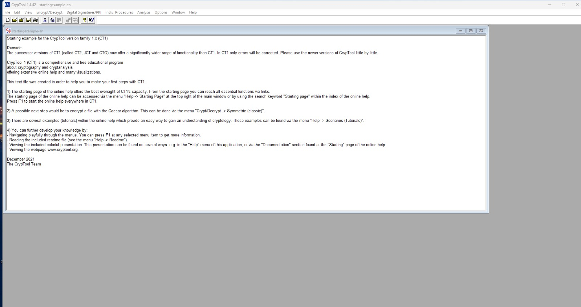

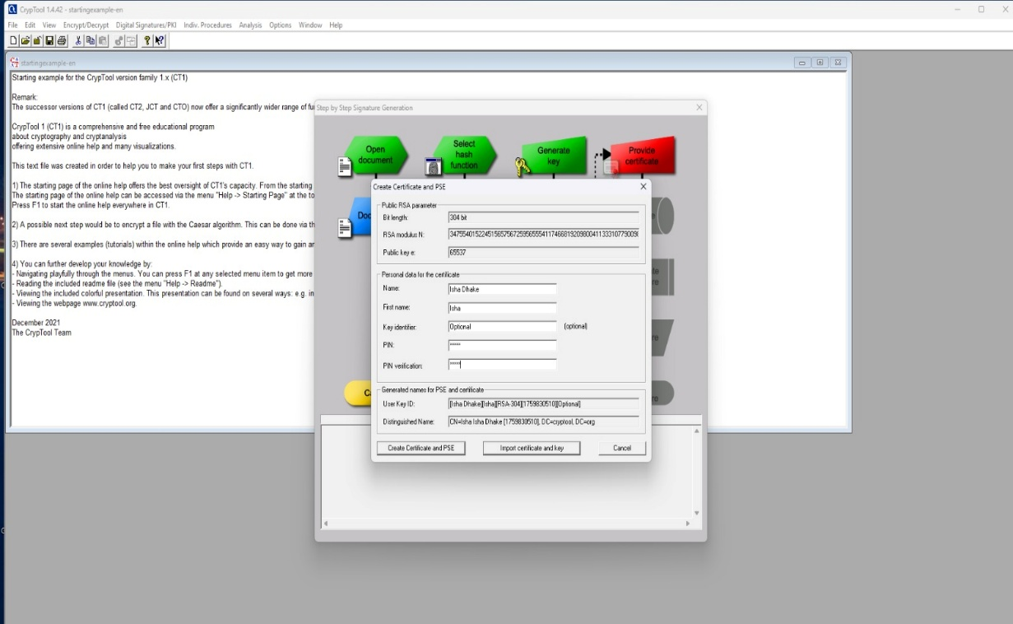

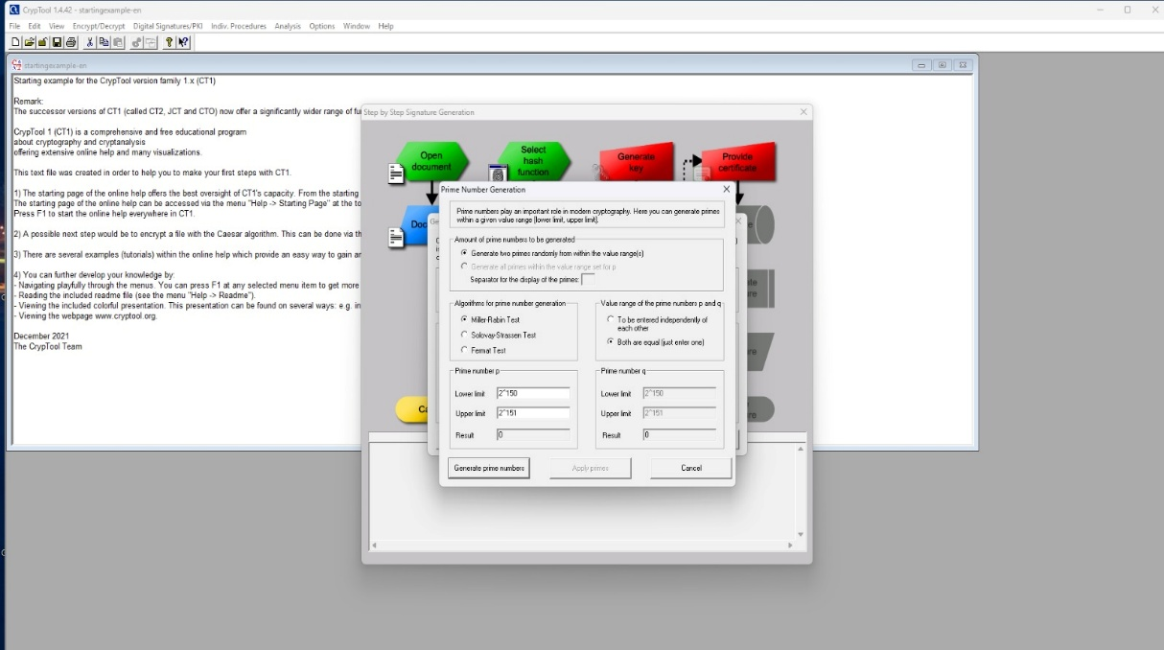

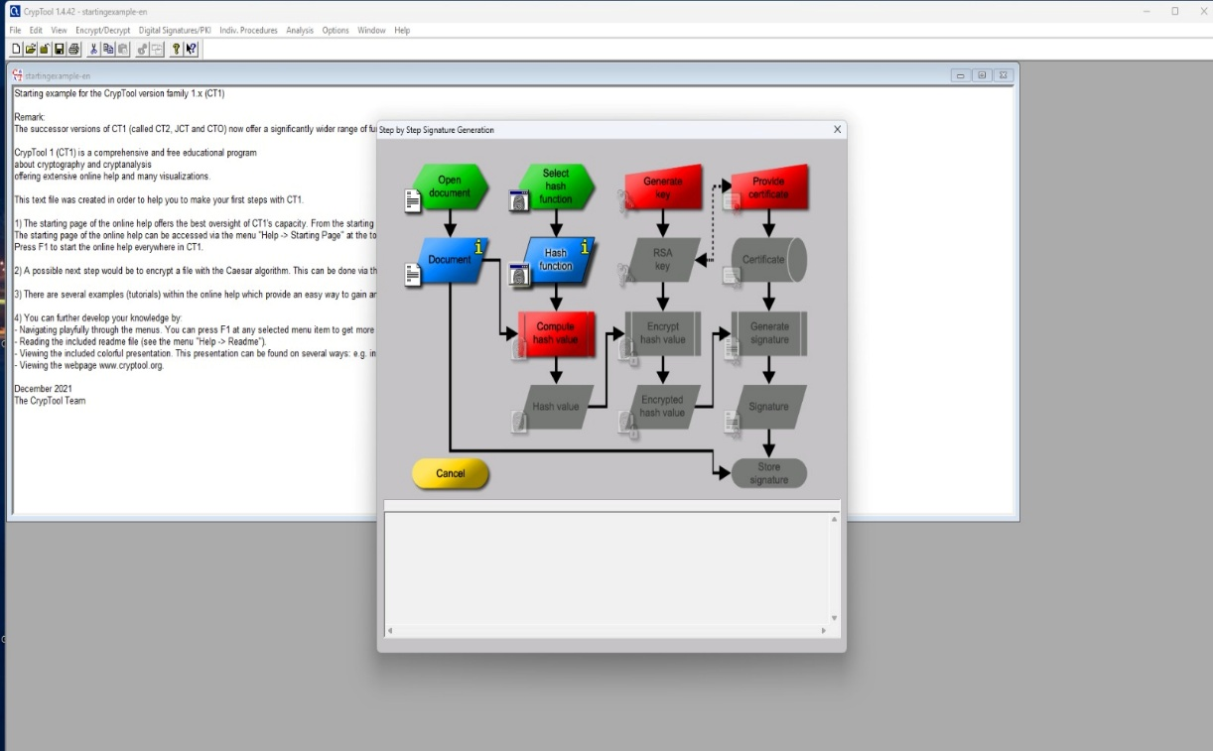

Conclusion:
I have successfully created and verified a digital signature, ensuring the authenticity and integrity of the message.

